BSCS – 2022
MUHAMMAD YOUNAS

EDUCATION & QUALIFICATION
University of Sargodha 2018-2022
BSCS
CGPA 2.84

Superior College Kotmomin 2018
ICS (Stats)
Subjects: Mathematics, Statistics, Computer

Govt. Higher Secondary School Bhabra 2016
Matriculation (Science)

PROJECTS
Research Project
Crop Guider (Research on crops in sargodha).
Object Oriented Analysis and Design
Design document of Hospital Management System
Database Systems
Hospital Management System
Multimedia
Slide show
Internet Architecture and Protocols
Multiprotocol Label Switching

ACTIVITIES, HONORS, & AWARDS
Member, Event Management Society- University of Sargodha 2018-2022

SKILLS & TOOLS
Tools: Android studio, Visual Studio, Xampp , Photoshop,
Filmora, Codeblock , devC++,
Microsoft Office, Eclipse, NetBeans, SPS,MS Visio Pro .
Skills: Android Development, Web Development (HTML 5),
Languages: C , C++, JAVA, HTML, CSS, PHP, MySQL, JS.

INTERESTS
Playing Games like cricket, farming and Fishing.

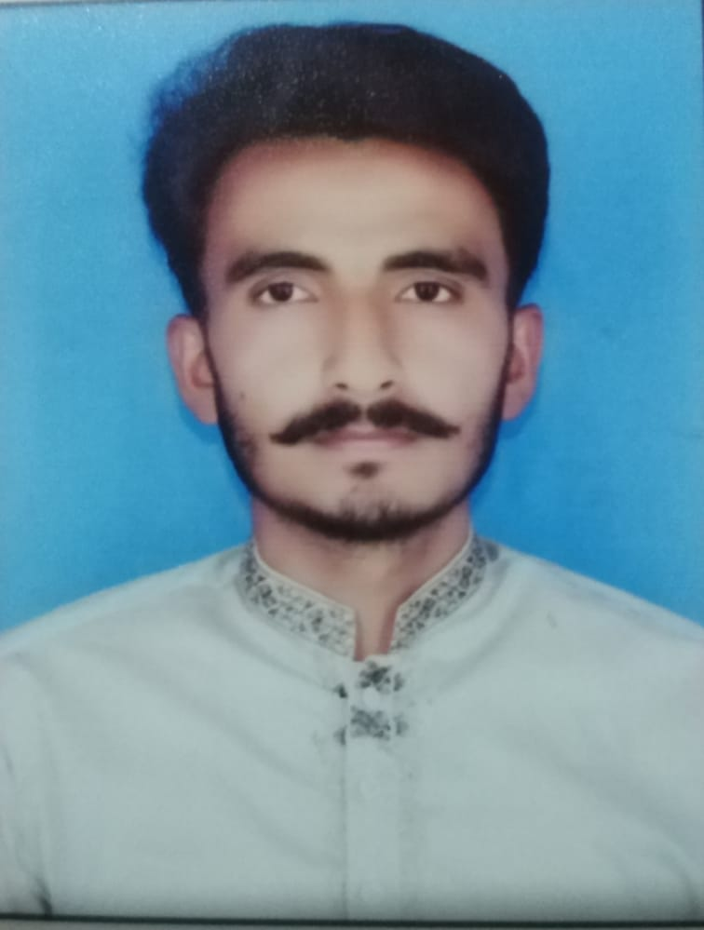

Date of Birth 12/06/2001
Business Address CS & IT Department
University of Sargodha University Road, Sargodha, Pakistan Tel: +92-48-9230811 Ext: 365
Cell: 030012131213
Email: placement@csit.uos.edu.pk

